EXPERIMENT NO. 6
Windows OS Commands — tracert, ping, ifconfig & netstat

Tool Used | Windows Command Prompt

Platform | Windows Operating System

Target | www.saveetha.com / 172.18.64.1
AIM
To execute and study basic Windows networking commands — tracert, ping, ifconfig, and netstat — for network enumeration and diagnostics.
TOOLS REQUIRED
- A Windows system with network/internet access
- Windows Command Prompt (cmd)
THEORY
Built-in command-line utilities are often the first tools used during network enumeration. tracert reveals the path and intermediate routers (hops) a packet travels through to reach a destination, which can expose network topology. ping checks whether a host is reachable and measures latency. ipconfig/ifconfig displays the local machine's network interface details such as IP address, subnet mask, and MAC address. netstat lists all active TCP/UDP connections and their current state, which is useful for spotting unexpected or suspicious connections.
PROCEDURE
Step 1: Open Windows Command Prompt and type the tracert command followed by the target: tracert www.saveetha.com → press Enter.
Step 2: Type the ping command followed by an IP address: ping <IP Address> → press Enter.
Step 3: Type the ifconfig (or ipconfig on native Windows) command to view network interface details.
Step 4: Type the netstat command to view active network connections.
COMMANDS USED
Command | Purpose | Example
tracert | Traces the route packets take to reach the destination host, hop by hop | tracert www.saveetha.com
ping | Tests reachability of a host and measures round-trip time | ping 172.18.64.1
ipconfig / ifconfig | Displays network interface configuration (IP, MAC, subnet mask) | ifconfig
netstat | Displays active network connections and their states | netstat
OUTPUT
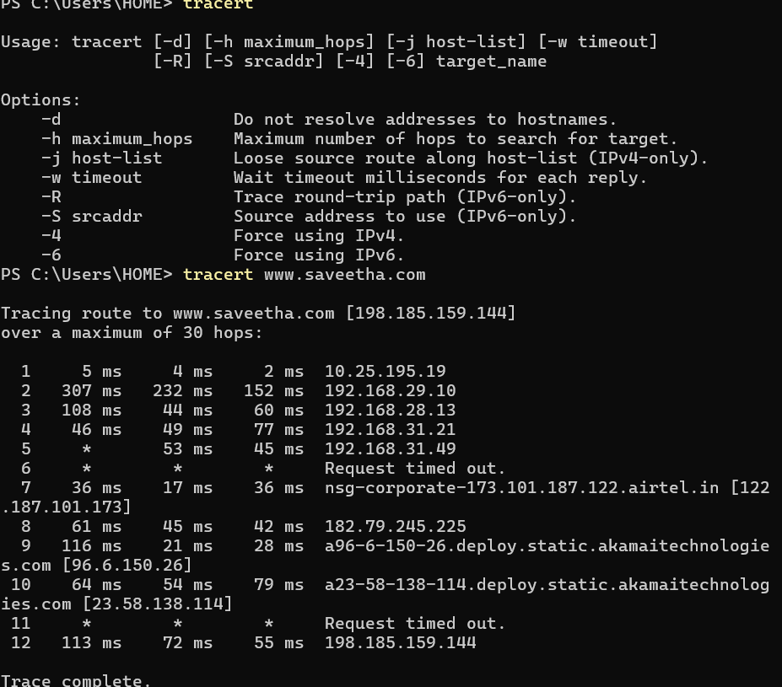

RESULT
Thus, the Windows networking commands tracert, ping, ifconfig, and netstat were successfully executed, and the network path, reachability, interface configuration, and active connections were studied.

